**Hotel Data - Revenue Insights**

* We have all the key matrices and below it shows the growth or decrease type.

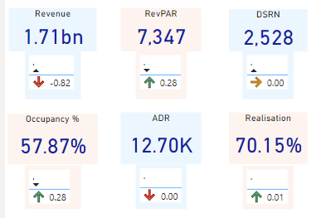

* Howring over the revenue will provide the graph of the trend

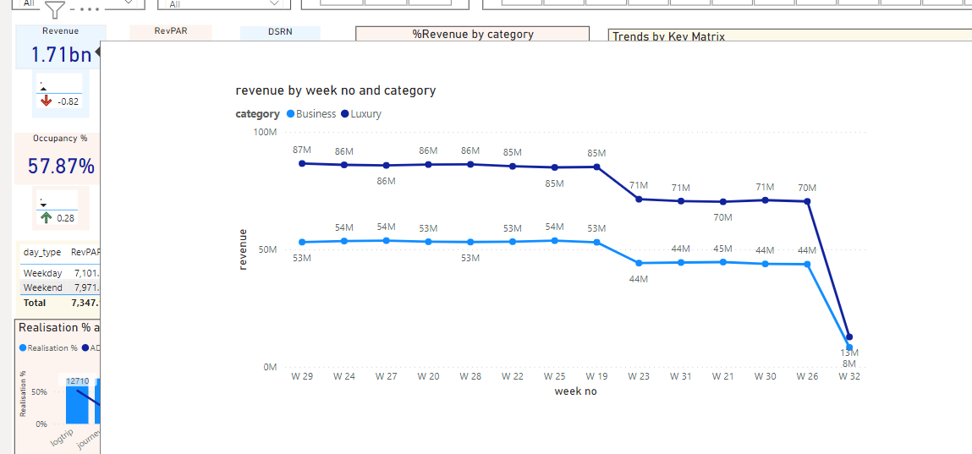

* Different filters are provided at the top to select as per need



* Trends by Key Matrix-

Straight line of ADR shows the Fixed price type of the hotel by looking at the data it does not shows that it is not using any pricing strategy

In month like may june july summer holiday so occupancy varies which is okay but prices are fixed week by week-- this show they are not using the dynamic pricing and have huge opportunity if they have the capabilities to adopt the dynamic pricing, even the weekday and weekend pricing

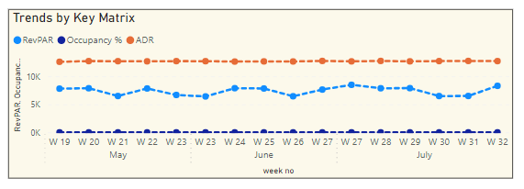

* Looking at the table also shows that the hotel has not opted for either the dynamic pricing or the weekday and weekend pricing as well so for the leisure hotel they can go for price change

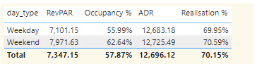

* Looking at the realisation % and the ADR by booking platform - they have highest selling at the offline and low price at their website where they can earn more profit

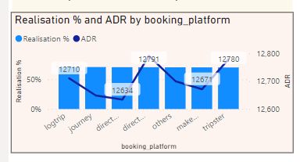

* Rating is very crucial in this industries, lowest rating hotel can make there digital presence strong and also focus on the services they offer

Customers are the best advisor / critic!

